A

**Web Development Project Report On**

“ONLINE BOOK STORE”

**SUBMITTED TO**

**KBC,North Maharashtra University, Jalgaon.**

# In the Partial Fulfilment of the Requirements of the Degree I-MCA 3rd

**SUBMITTED BY:**

## Mr. Dnyandip Subhash Nehete.

Email id: [dnyandip40@gmail.com](mailto:dnyandip40@gmail.com)

**Academic Year: 2024-25**



**KCES’s Institute of Management & Research, Jalgaon**

# DECLARATION

This is certified that the Project Work entitled ***“ONLINE BOOK STORE"*** submitted by me for the partial fulfilment of the I-MCA3rd offered by the **Institute of Management & Research, Jalgaon** during the academic year 2024-2025 is an original work carried out by me under the guidance of ***Ms. Deepali Kirange*** and this work carried has not formed for the award of any Degree, Diploma or such other titles.

**Date: Mr. Dnyandip S. Nehete**



# CERTIFICATE

This is to certify that **Dnyandip Subhash Nehete** a student of I-MCA 3rd year from KCES’S Institute of Management and Research; Jalgaon has completed the project work entitled “**Online Book Store”.** He has submitted satisfactory project report in partial fulfillment of the requirement for the degree of IMCA during academic year 2024-2025.

It is the original work and sincerely completed. I am fully satisfied with his/her performance.

Ms. Deepali Kirange Ms. Rupali Narkhede Dr. Tanuja Fegade Prof. Dr. B.V.Pawar

#### Internal Guide Coordinator HOD Director

**External Examiner I External Examiner II**



# ACKNOWLEDGEMENT

We take this opportunity to express our deepest and special appreciation to our guide **Ms. Deepali Kirange** for her insightful advice, motivating suggestions, invaluable guidance, help, and support in the successful completion of this project report. We express our deep gratitude to our head of the department, **Dr.Tanuja Fegade**, and our director, **Prof. Dr. B.V Pawar** for their co-operation and coordination. We would like to convey our thanks to the teaching and non-teaching staff of our college for their help. We are also grateful to all our friends and classmates for their help and encouragement. Finally, yet, more importantly, we would like to express our deep appreciation to our parents for their perpetual support and encouragement throughout the completion of the report

#### With Warm regards, Dnyandip Nehete

**I-MCA 3rd**

# INDEX

|  |  |  |
| --- | --- | --- |
| **Sr. No.** | **Particulars** | **Page No.** |
| 1 | Abstract | 1 |
| 2 | Introduction | 2 |
| 3 | Purpose and Scope | 3 |
| 4 | Proposed System | 4 |
| 5 | Need Of The System | 5 |
| 6 | Software & Hardware requirements | 6 |
| 7 | Diagrams | 8 |
| 8 | Database Design | 14 |
| 9 | Screen Shots | 18 |
| 10 | Conclusion | 27 |
|  | References | 28 |

**ABSTRACT**

The Internet by far plays a major role in people’s life. It has drastically improved the quality of life and the standard of living of so many people. It has widened its branches into many different levels and areas. The ecommerce industry is one such branch which has come into spotlight in the recent years.

The online book store system has eased the life of so many book lovers by making it easy for them to purchase books online. It is not always feasible to access a traditional bookstore, it is limited by its operation time, availability of a particular book, its location and most importantly its capacity and the space required to store numerous books.

Such drawbacks have led to the evolution of e-commerce industries related to bookstores. Our project is one such simple e-commerce website which houses various books of different categories for a consumer to purchase online.

# 1. INTRODUCTION

An online bookstore software projects that acts as a central database containing various books in stock along with their title, author, and cost. This project is a website that acts as a central bookstore. This web project is developed using PHP as the front end and SQL as a back-end.

The SQL database stores various book related details. A user visiting the website can see a wide range of books arranged in respective categories. The user may select desired book and view its price. The user may even search for specific books on the website. Once the user selects a book, he then has to fill in a form and the book is booked for the user.

The software has the following three main components: -

#### Implement of new user to register and login.

1. **Implement user to choose any book.**

#### Implement the user to buy books.

The website will be implemented using PHP as the programming language. MYSQL database will be used to link database.

For the project, we propose to build an online bookshop for People. The online bookshop will contain stories, study material, any courses books like computer and be available to everyone. Many students find textbooks too expensive to buy at school bookstores and many courses only use the required textbooks a few days in a semester.

This becomes very wasteful and frustrating for other people. This online bookstore provides a solution to this. It will provide a service in which students can buy books online without any treble. There will be free shipping. They do need to register with the site to books. Payment information will be requested after adding any numbers of books in the cart.

# PURPOSE AND SCOPE

## Purpose

**Online Book Store** would have the following goals.

* + Provide a web user interface to add, view, delete records in different areas.
  + Provide a user interface to enter computer details.
  + Provide a user interface to change details of all the computers and accessories.
  + Provide a user interface for users to explore the store and choose items to buy.

## Scope

The main scope and deliverables of the project would be to:

* + Understand and prepare detailed requirement and specifications.
  + Prepare high level and detailed design specifications of the system.
  + Develop the system and coding.
  + Perform unit testing, integration, and system testing.
  + Demonstrate a bug free application after suitable modification if needed.

## Achievements

* + By successfully implementing the project, a substantial knowledge has been acquired on the implementation of a database system using .net technologies.
  + This knowledge will be useful in the future in creating any type of desktop application or online database systems.

# PROPOSED SYSTEM

Online Book Store Project is a Web-Based Online e-book Shopping Project. It is the graphical user interface.

It has a form for user to input query information to search the books from database.

The control function is designed to process the input from the user's interface, generate the searching query and then gets data from the database and returns to the user's interface.

## System Actors & Actors Features.

The system has two major actors and each actor has its features to carry out as follows:

**Admin :**Admin is the person who controls, monitors and keeps the whole records of Books. The main functions of the Admin are:

* + Add/update/Delete Books Records
  + Check the existing users
  + Check the Book orders from different users

**User:** User is the person who want to Purchase any Books. The main functions of the users are:

* + User Registration
  + User Login
  + Check the details about us
  + Contact to Admin
  + Search Book
  + Add to Cart book
  + Payment at delivery.

# NEED OF THE SYSTEM

## Need for the New System

* + Online Book Store is a specific requirement of the client that integrates the buying and selling services specifically to their customers.
  + Reports can be generated at any time within few seconds, so that manual labor is not required, and analysis can be performed much more frequently which helps in taking decision.
  + The details regarding all users, books can also be maintained as their information is very helpful and sometimes becomes a critical requirement.
  + Allows user to get registered from their places and transact for the required product.
  + To overcome these problems, we develop “**Online Book Store”.**

## Functional Requirements:

The System must provide following functionalities—

* + Keeping records of registration of customers.
  + Keeping the records of books.
  + Keeping the daily sell.
  + Storing the feedback given by the customer.
  + Keeping details about the product it is delivered or not. etc.
  + Storing the items selected by the customer in the temporary storage.

## Non-Functional Requirements:

Following Non-functional requirements will be there in the online shopping portal.

* + Secure access of confidential data (customer’s details).
  + 24 X 7 availability.
  + Better component design to get better performance at peak time.

# SOFTWARE & HARDWARE REQUIREMENTS

A major element in building system is selection of compatible hardware and software Hardware selection they begin with requirements analysis following by a request for proposal, evaluation & validation, post installation review. While selecting the software, various criteria is considered such as reliability (gives consistent results), functionality (function to standards), capacity (satisfies volume requirements), flexibility (adapts to changing needs), usability (user friendly), security (to prevent unauthorized access), performance (capacity to deliver as expected), serviceability (good documentation), minimal cost (affordable for intended application).

#### TECHNOLOGIES USED

* + **Server-Side Scripting**: PHP
  + **Database Tool:** My SQL
  + **Testing Server:** Apache
  + **Client-Side Scripting:** HTML, CSS, JavaScript

#### SOFTWARE REQUIREMENTS

* + Windows Vista or above
  + Xampp Server 2.5 or above.
  + My SQL Server.

#### HARDWARE REQUIREMENT

* + Processor – 2.5 GHZ
  + Ram – 2 GB MB.
  + Hard Disk-50 GB
  + Monitor
  + Mouse
  + Keyboard

#### BRIEF OVERVIEW OF THE TECHNOLOGY FRONT END: HTML, CSS, JAVASCRIPT

1. **HTML**: HTML is used to create and save web document. E.g.Notepad/Notepad++
2. **CSS** : (Cascading Style Sheets) Create attractive Layout
3. **JavaScript**: it is a programming language, commonly use with webbrowsers.

#### BACK END: PHP, MYSQL

1. PHP: Hypertext Preprocessor (PHP) is a technology that allows software developers to create dynamically generated web pages, in HTML, XML, or other document types, as per client request. PHP is open-source software.
2. MySQL: MySQL is a database, widely used for accessing querying, updating, and managing data in databases.

# DIAGRAMS

## A.DATA FLOW DIAGRAM

The Data Flow Diagram shows the flow of data or information. It can be partitioned into single processes or functions. Data Flow Diagrams can be grouped together or decomposed into multiple processes. There can be physical DFD's that represent the physical files and transactions, or they can be business DFD's (logical, or conceptual).

#### Its used by:

It is a useful and easy to understand modelling tool. It has broad application and usability across most software development projects. It is easily integrated with data modelling, workflow modelling tools, and textual specs. Together with these, it provides analysts and developers with solid models and specs. Alone, however, it has limited usability. It is simple and easy to understand by users and can be easily extended and refined with further specification into a physical version for the design and development teams. The different versions are Context Diagrams (Level 0), Partitioned Diagrams (single process only -- one level), functionally decomposed, levelled sets of Data Flow Diagrams.

**I Level 0:**

Books & other details

Order receipt & confirmation

Order & reports

Online

Book Store

Personal Details & Select product.

Admin

User

**Fig: 1 CONTEXT DIAGRAM**

### II Level 1:

Status

Data

1.0

Admin Process

Store

Product

Book

process

Admin

**Fig 2: DFD for Admin Process**

### Level 2:

Enter data.

status

Registration Process

2.0

User Details

Register

User

**Fig:3 DFD For User Registration**

### Level 3:



Select Product

Book info

Book

|  |
| --- |
| Login  User |
| order |

**Fig:4 DFD for shopping and checkout process:**

Add to Cart

3.1

Selected Product

confirms

Checkout

Cart Details

Place Order

Cart

Order

User

### B. Entity-Relationship Model

Simply stated the ER model is a conceptual data model that views the real world as entities and relationships. A basic component of the model is the Entity-Relationship diagram which is used to visually represent data objects. Since Chen wrote his paper the model has been extended and today it is commonly used for database.

### ER Diagram:

User_type

pin country

state

password

email users

name

city

**One-to-many**

**Relation**

address

Id

**Primary Key**

Choose items

name

details

User_id

pid

id price id

name

image

**Many-to-Many Relation**

Book

B_publish

Adds to

Cart price

quantity

page

confirms

Write query

image

orderID

Cart_id

query

order

email contact

Order date

con_id usern

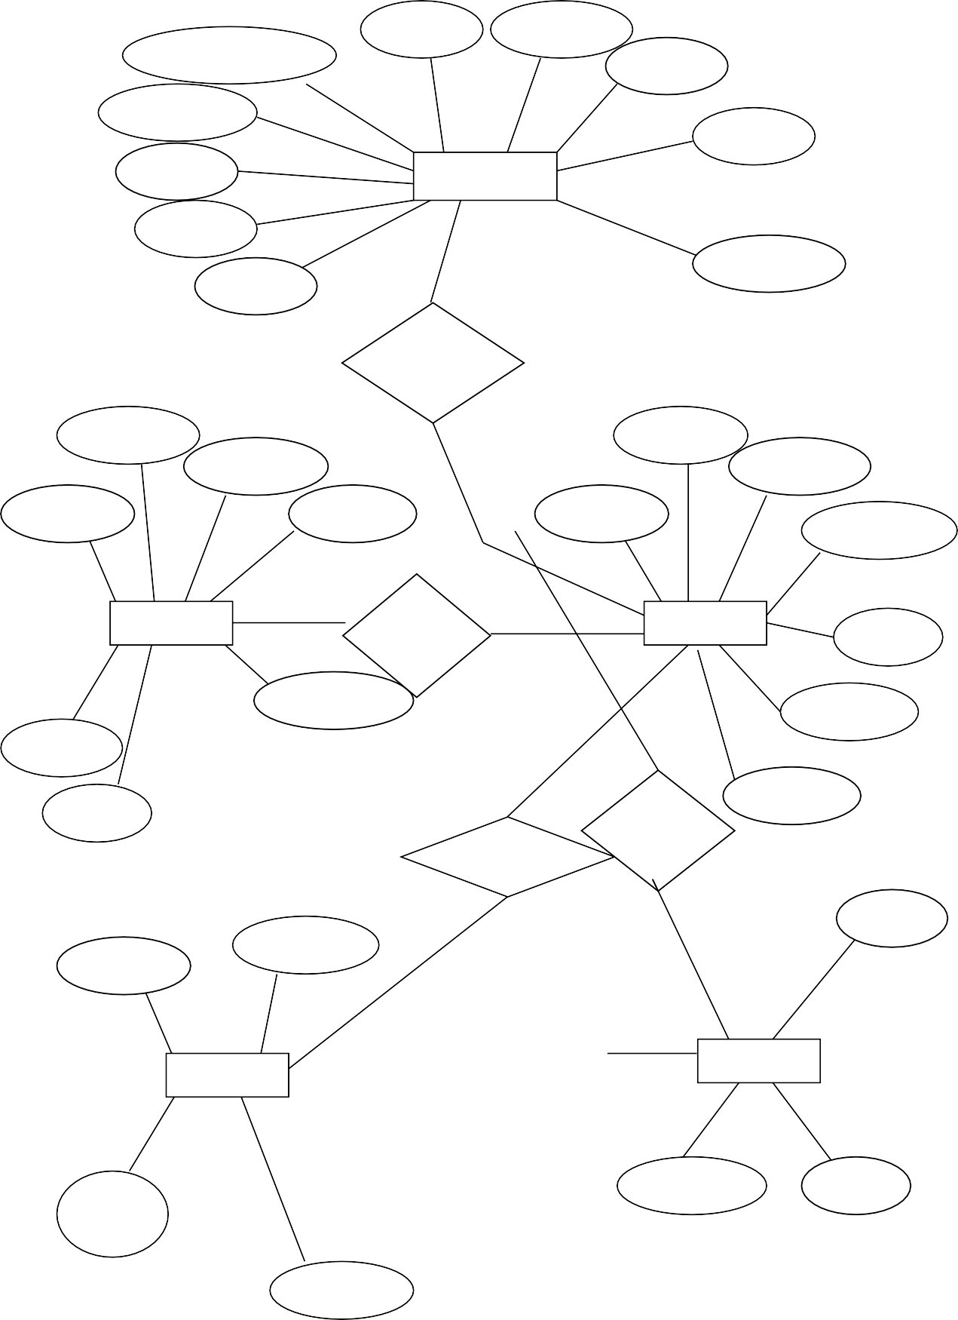

amount

**One-to-Many**

**Relation**

### C. Use Case Diagram

In the Unified Modelling Language (UML), a use case diagram can summarize the details of your system's users (also known as actors) and their interactions with the system. To build one, you'll use a set of specialized symbols and connectors. An effective use case diagram can help your team discuss and represent:

Scenarios in which your system or application interacts with people, organizations, or external systems

Goals that your system or application helps those entities (known as actors) achieve The scope of your system



Register

Login

Update

profile

Place order

User

Update cart

View cart

Logout

### Use Case Diagram: Fig 1



Login

Add or Book

Manage Order

Add or Delete

Admin

Logout

**Use Case Diagram: Fig 2**

# DATABASE DESIGN

### A.DATABASE DESIGN

The general theme behind a database is to handle information as an integrated whole. A database is a collection of inter-related data stored with minimum redundancy to serve single users quickly and efficiently. The general objective is to make information necessary, quick, inexpensive, and flexible for the user.

### Database Tables

* + Table structure for table `cart`:

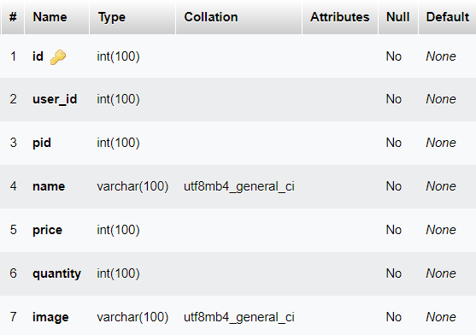

* + Table structure for table `message`

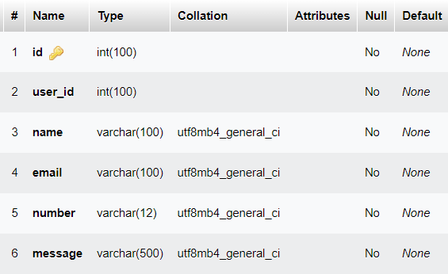

* + Table structure for table `orders`

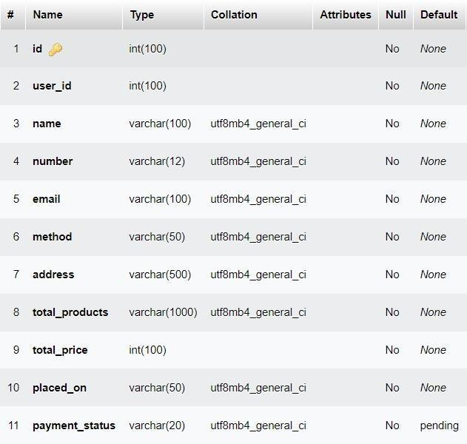

* + Table structure for table `products`’

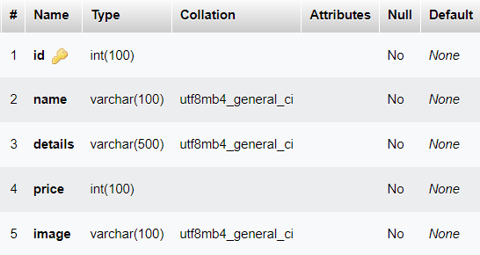

* + Table structure for table `users`

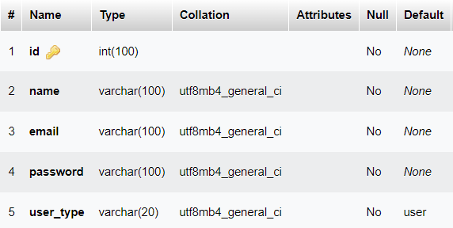

* + Table structure for table `wishlist`

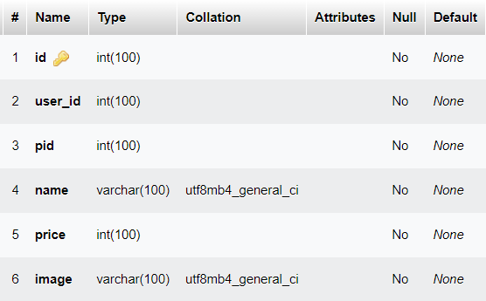

# PROJECT SCREENSHOTS

Screenshots of a project are visual representations of the interface and functionality of a software project. These screenshots are usually captured during the development process and can be used for various purposes, such as documentation, testing, and demonstrations.

Screenshots of a project are essential in documenting, testing, and demonstrating the functionality of a software project.

#### HOME PAGE:

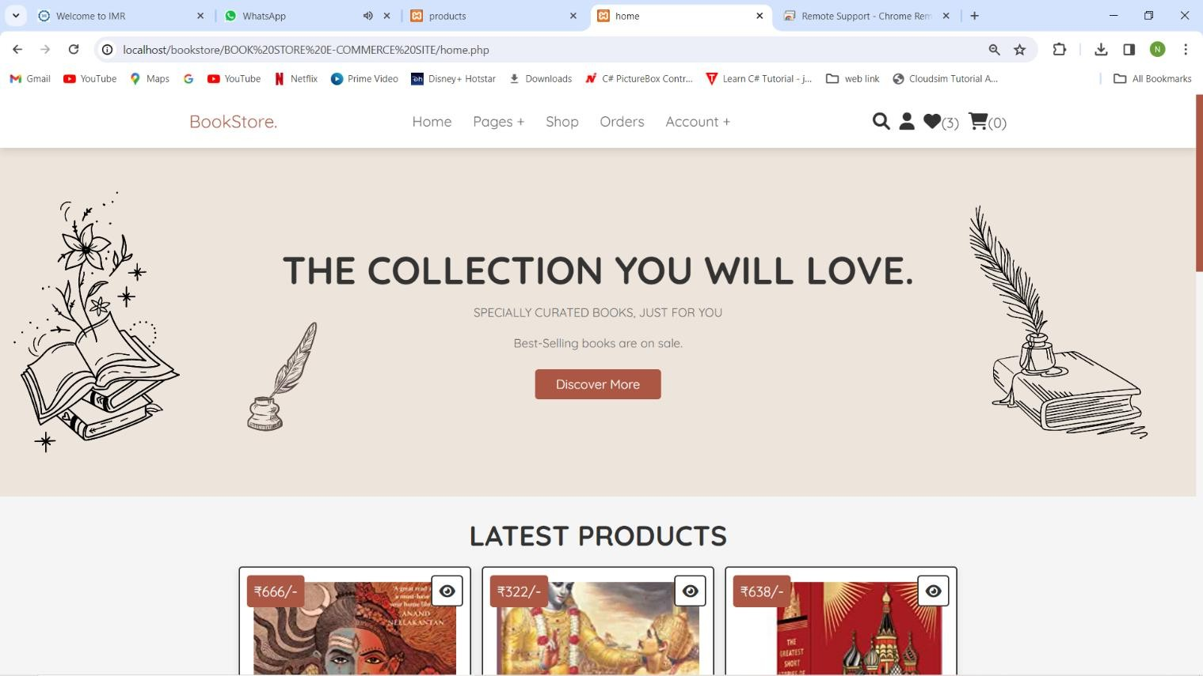

* REGISTRATION PAGE:-

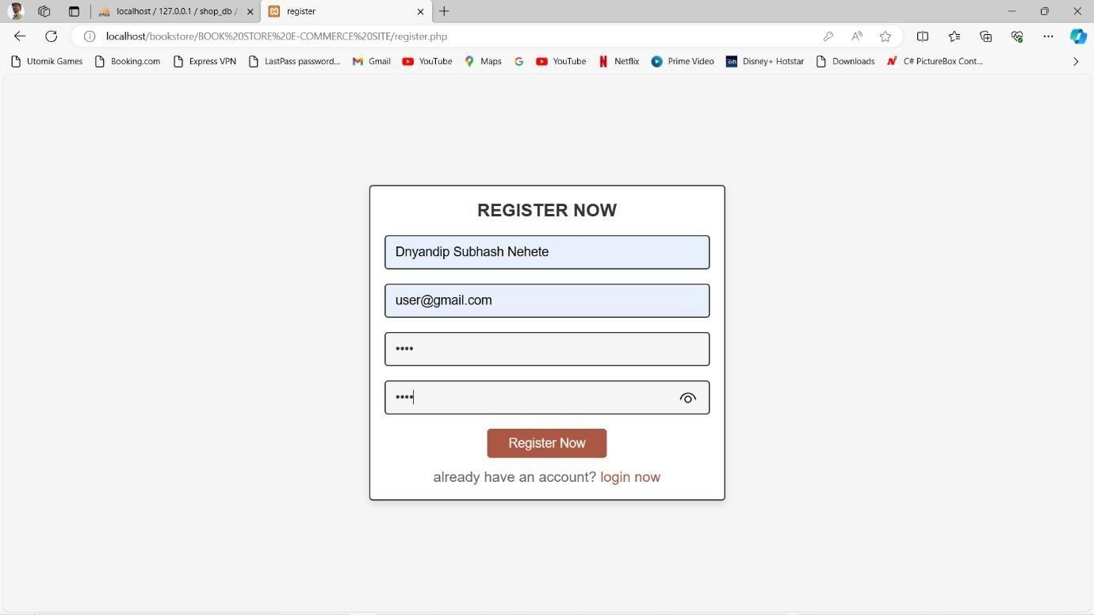

#### LOGIN PAGE

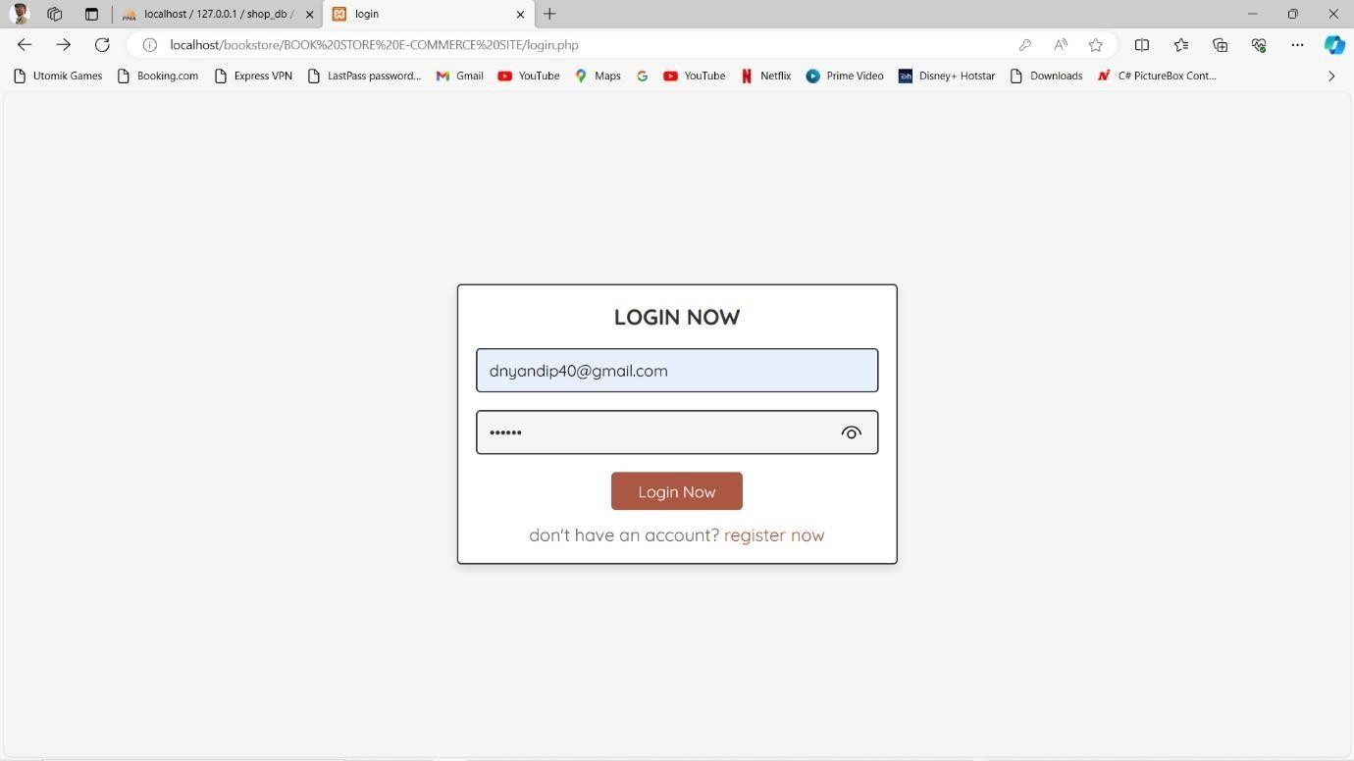

* + **SHOP PAGE**

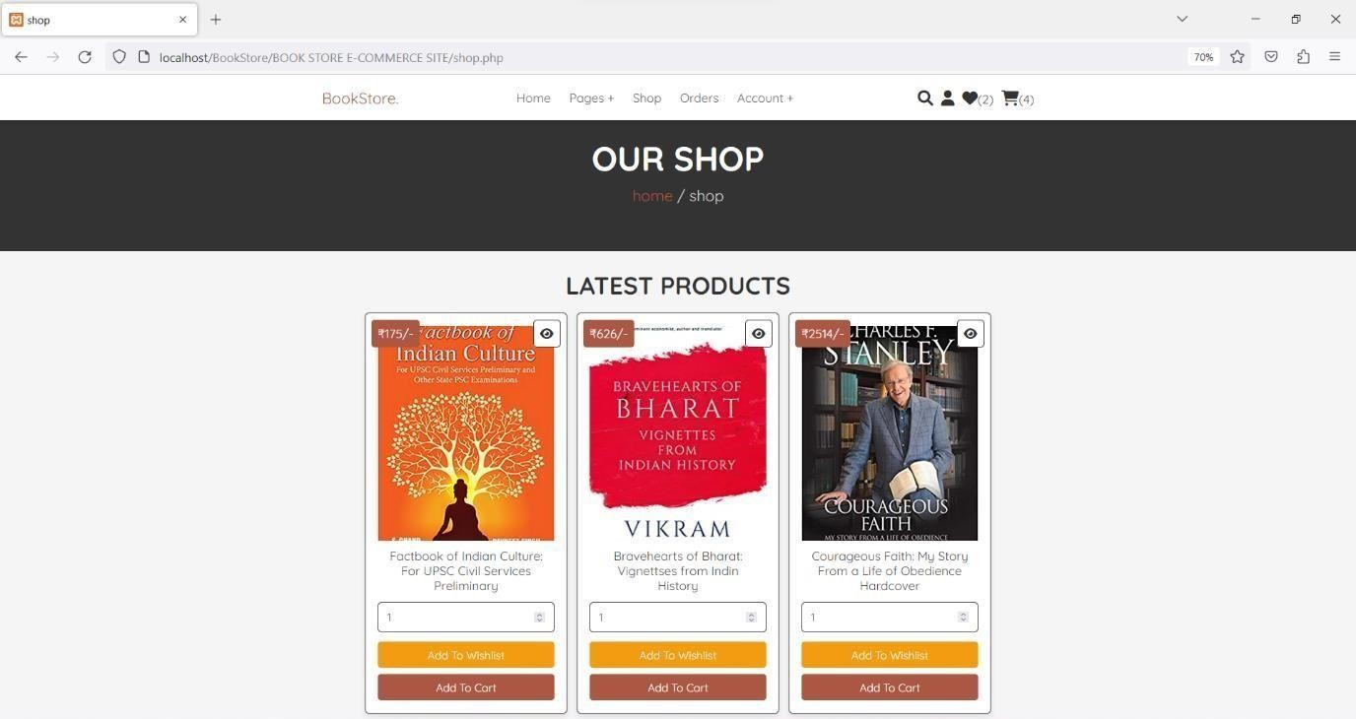

#### ABOUT US

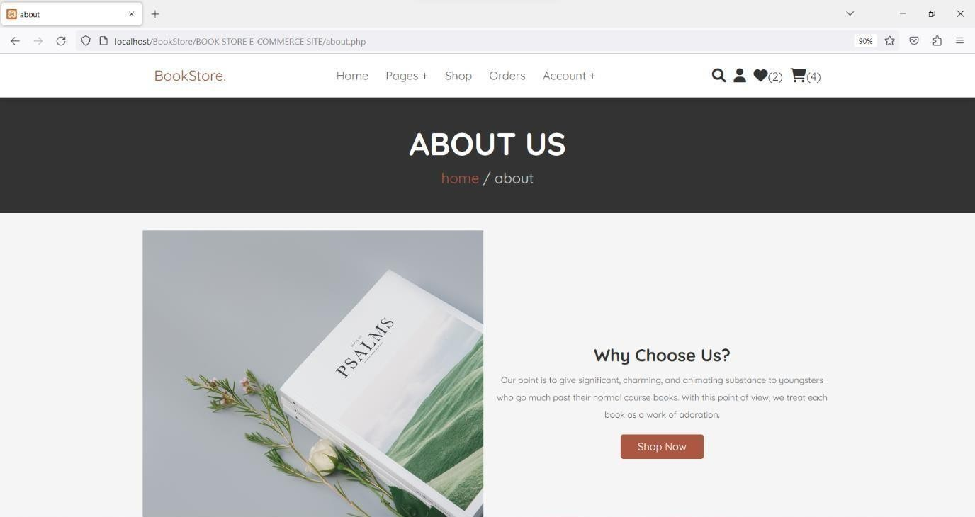

* + **SHOPPING CART**

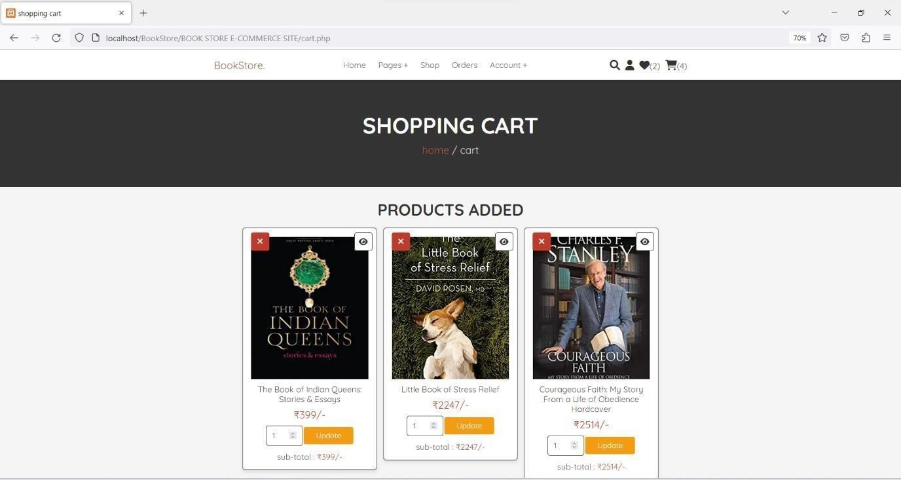

#### YOUR WISHLIST

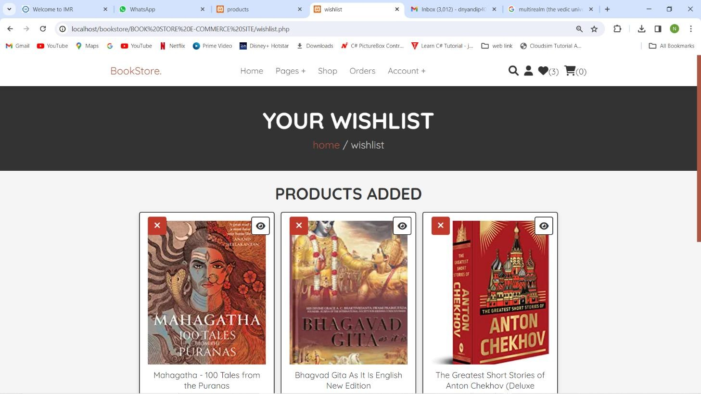

**21 |** P a g e

* CONTACT US

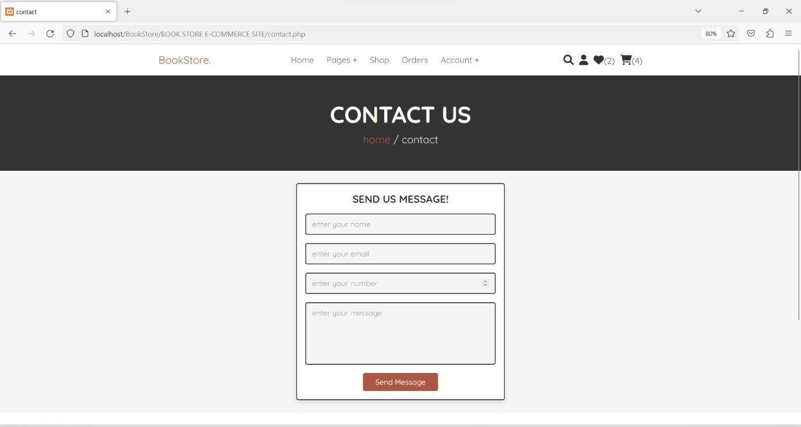

#### WishList:-

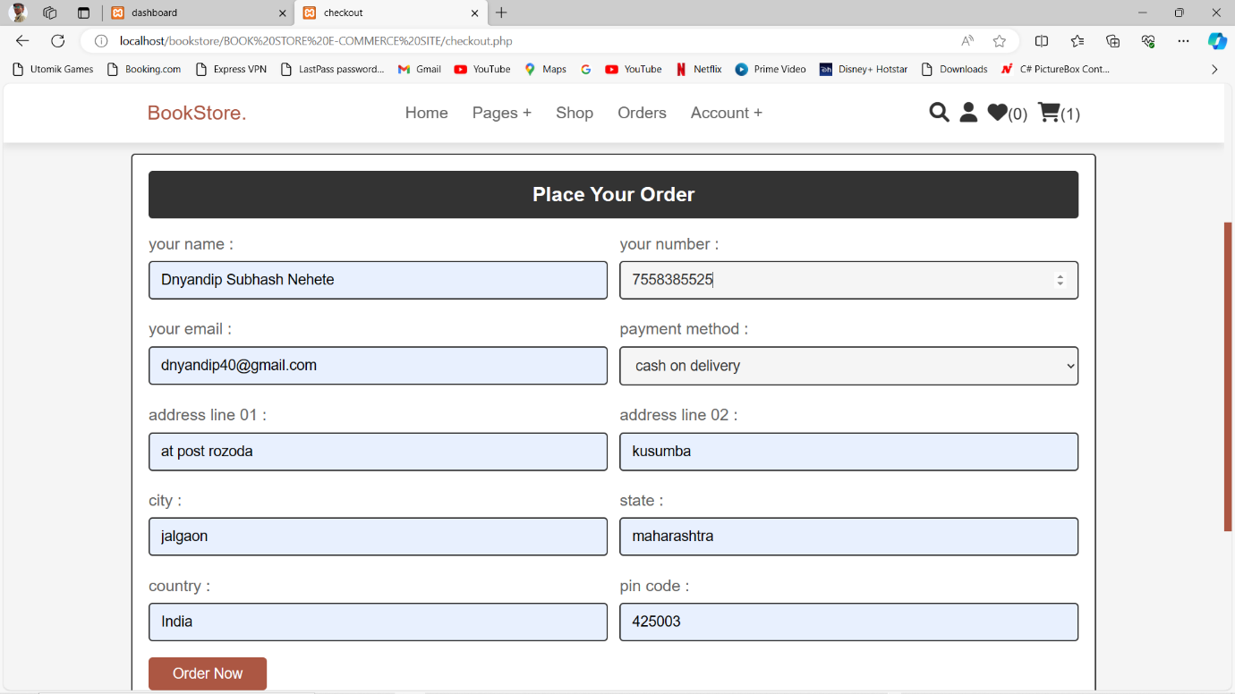

* + **PlACED ORDER**

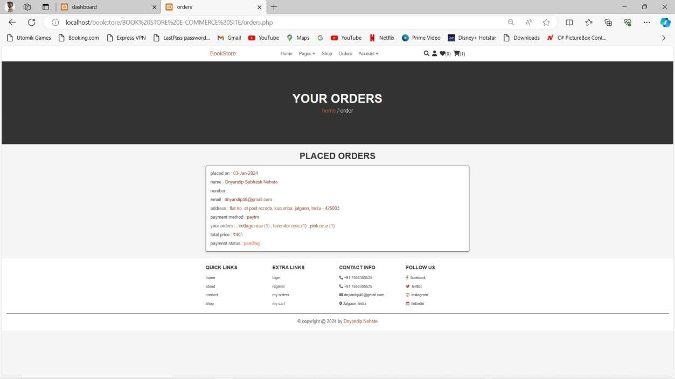

#### Search Page

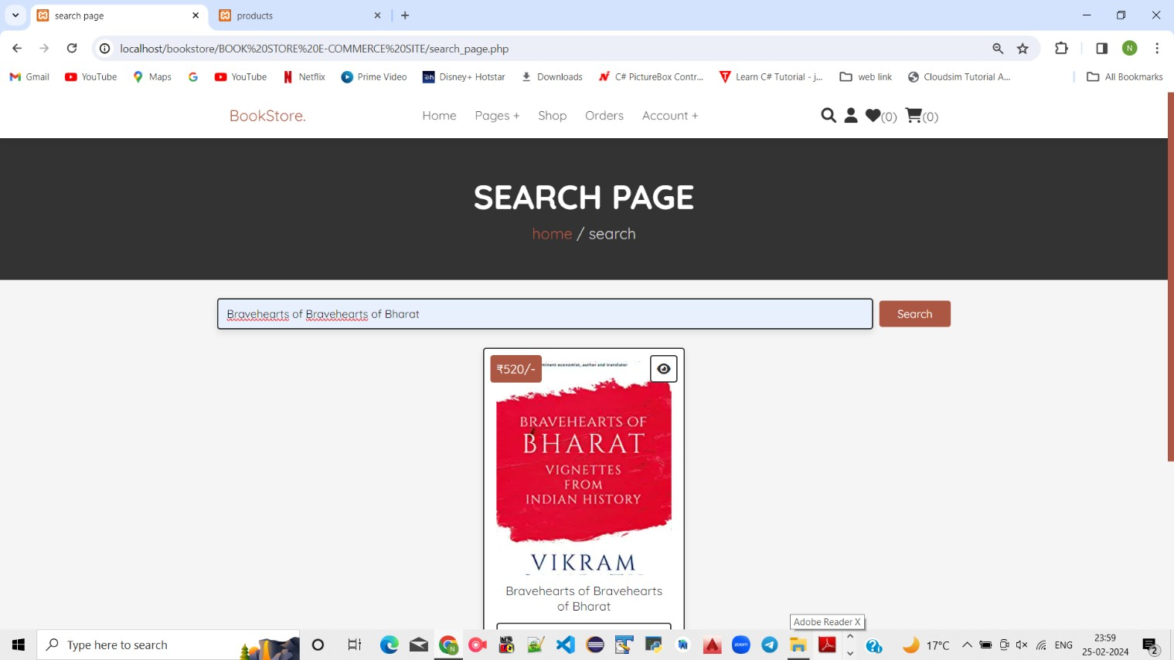

* + **ADMIN PANEL**

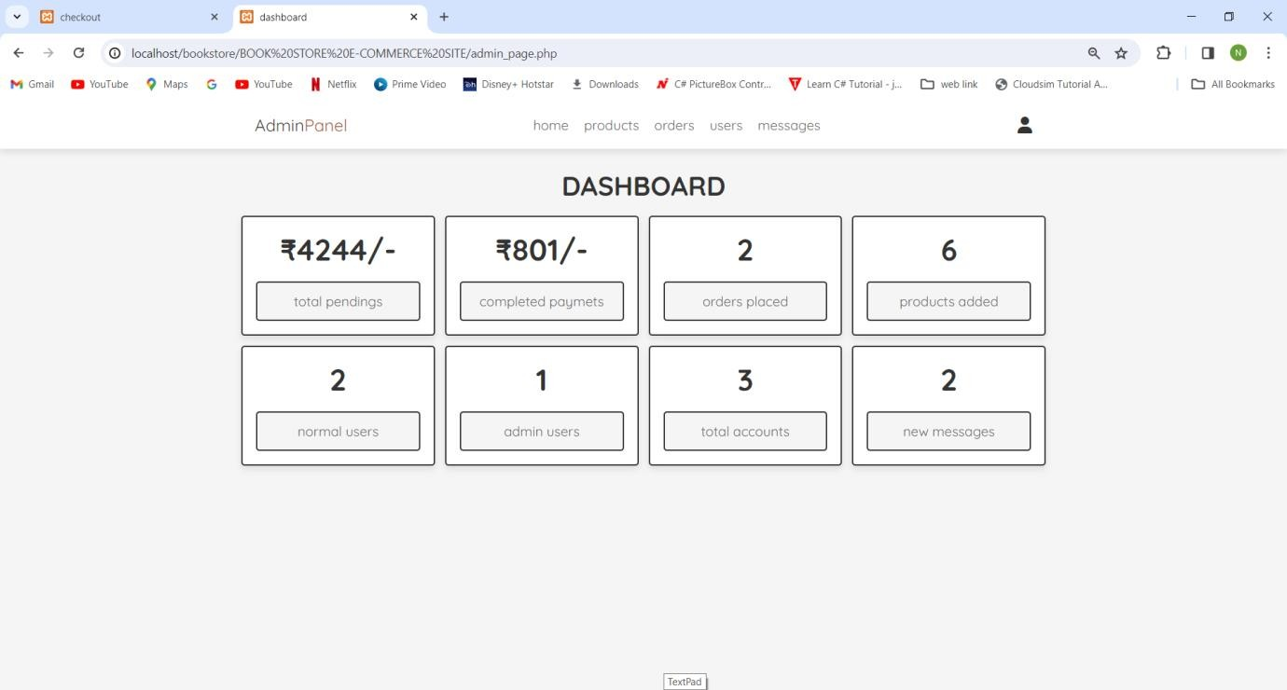

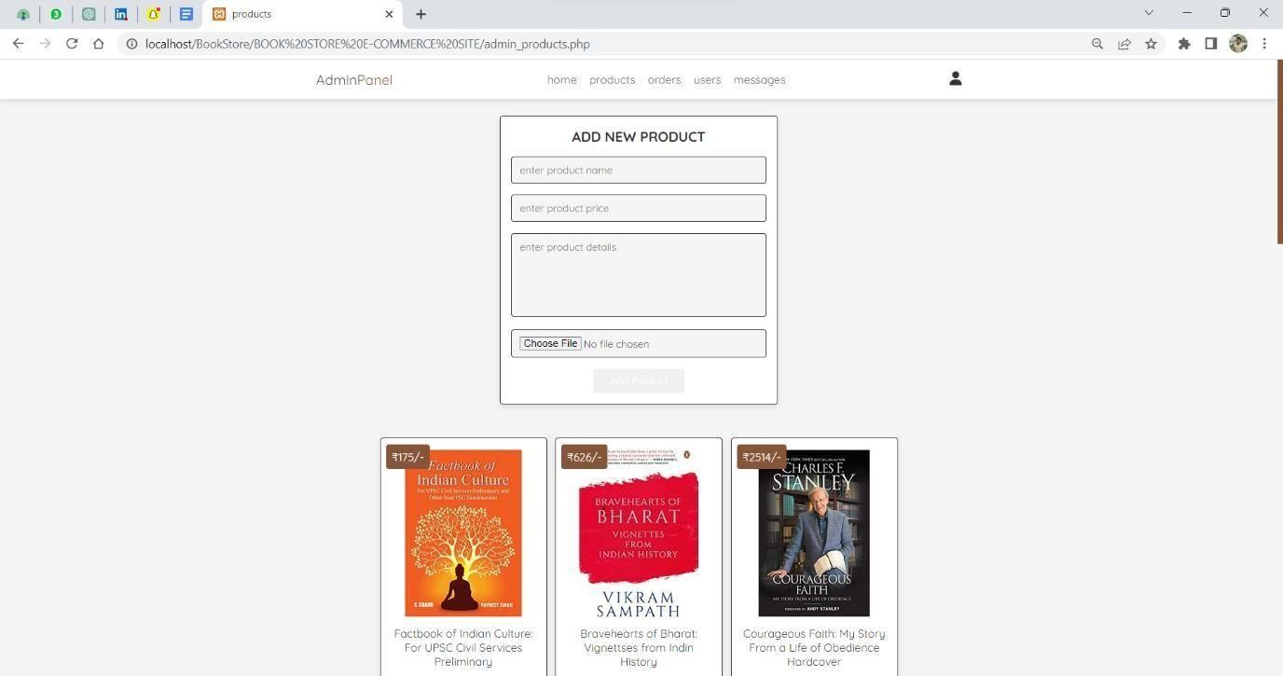

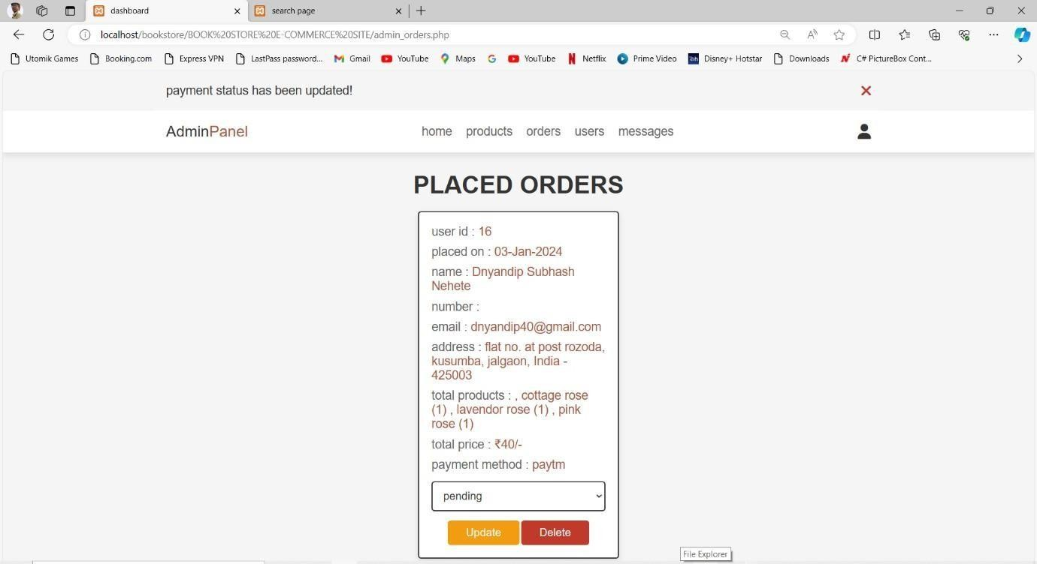

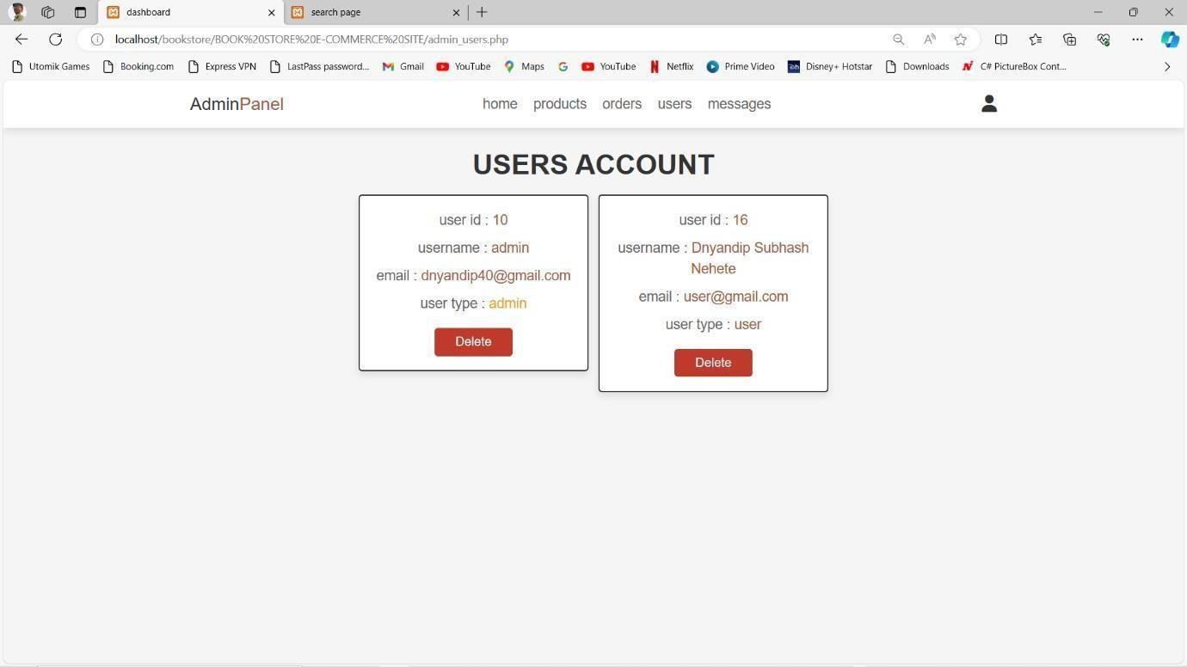

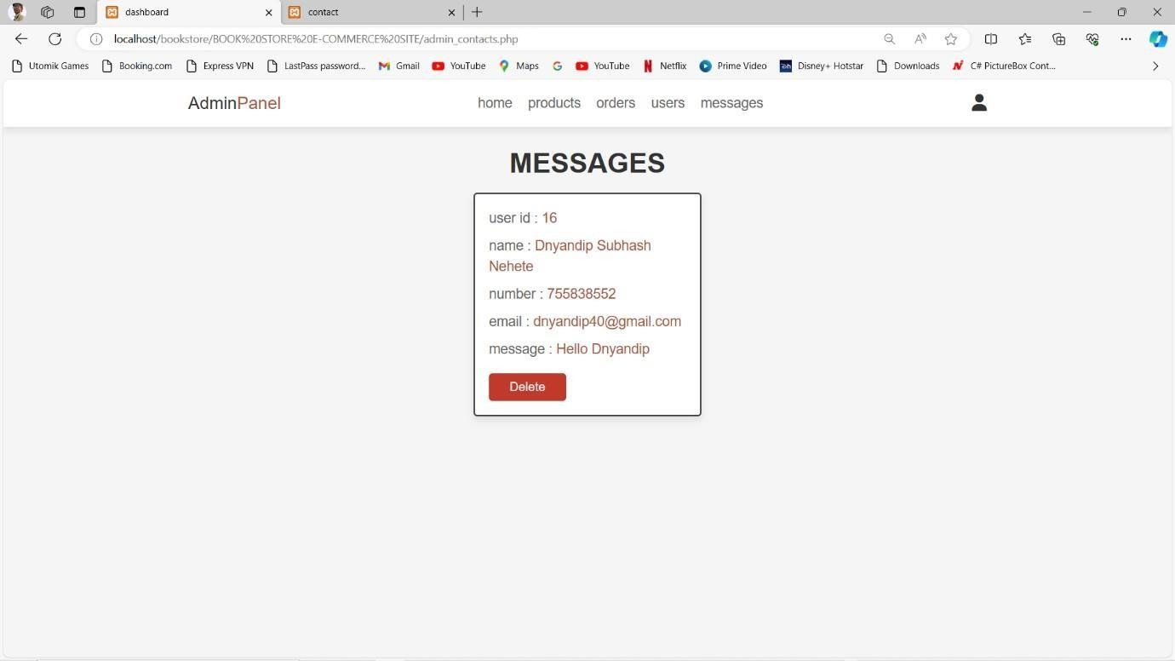

# CONCLUSION & FUTURE SCOPE

Online bookstore has many advantages compared to its counterparts such as physical book store, the online bookstore allows it's user to shop at one place where in physical store the books are scattered at the different places which consumes a lot of time and online bookstore helps in saving that time and it also avoids the problem of unavailability of books at physical store as numerous vendors from different places sell their books at one place.

#### There are some limitations for the current system to which solutions can be provided as a future development:

1. The Website is not accessible to everyone. It can be deployed on a web server so that everybody who is connected to the Internet can use it.
2. Credit Card validation is not done. Third party proprietary software can be used for validation check.

#### As for other future developments, the following can be done:

1. The Administrator of the web site can be given more functionality, like looking at a specific customer’s profile, the books that have to be reordered, etc.
2. Multiple Shopping carts can be allowed.

This project is efficient in maintaining users records and can perform operations on it, also reduces the workload on the shop owner of knowing the quantity of books available and which books are available and keeps the records of how many books are purchased and sold.

# REFERENCES

* 1. <https://en.wikipedia.org/wiki/Bookselling>
  2. <https://www.techopedia.com/definition/23889/web-development>
  3. <http://php.net/manual/en/intro-whatis.php>
  4. <https://www.mysql.com/about/>
  5. <https://en.wikipedia.org/wiki/MySQL>
  6. <https://www.w3schools.com/php/php_mysql_intro.asp>
  7. Rob Larsen, (2013),Beginning HTML and CSS, ISBN: 9781118340189
  8. J. Ullman,(2010), “Principles of Database Systems”, GALGOTIA Publications, ISBN : 9788120346741
  9. R. S. Pressman,(1992), Software Engineering – A practitioner’s approach, 3rd ed., McGraw Hill Int. Ed., ISBN : 007301933X